
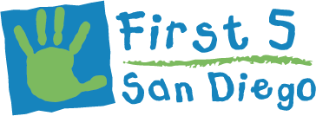

Take advantage of various FREE
Workshops on early childhood development, ages 0-5 years old.
Chula Vista Promise Neighborhood offers:
-Personalized support for parents
- Parent education on health, child development and behavior support
-Positive discipline techniques
-Linkage to community resources
-Financial Literacy
-Developmental Screening

…and much more!

Classes offered at:
Loma Verde Elementary
1/16-3/6: (8 wks) 8:15-9:45
Parenting/Development

Harborside Elementary
1/24-3/21: (8 wks) 8:45-10:15
Behavior Series

Castle Park Elementary
1/28 & 1/30 (8 weeks) 8:30-10
Parent/Child Development

2/1 – 3/22 (8 weeks) 8:30 - 10
Behavior Series

*Talleres disponibles en Español
*Childcare available
For more information:
619-422-5005

*Child care available
*Incentives and certificates provided
upon program completion!

parenting workshops

SouthBayCommunityServices.org | 619-420-3620

