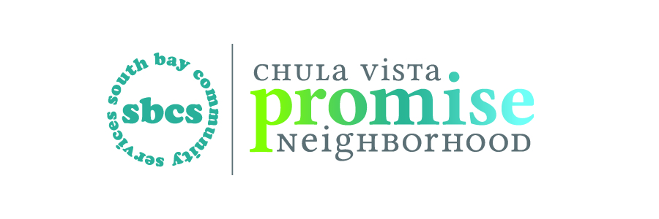

Escuelita del futuro

Free Preschool Program for Children Living in the Castle Park Community

Escuelita Del Futuro helps children get ready for Kinder through educational, social and language experiences.

Who Can Enroll?
Children 3-5 living in the
Castle Park community or have children enrolled in Castle Park, Loma Verde or Harborside Schools.

Where Located?
Castle Park Elementary, Room 701
25 Emerson St.
Chula Vista, CA 91911
(Corner of Hilltop and Oxford)

Free Program

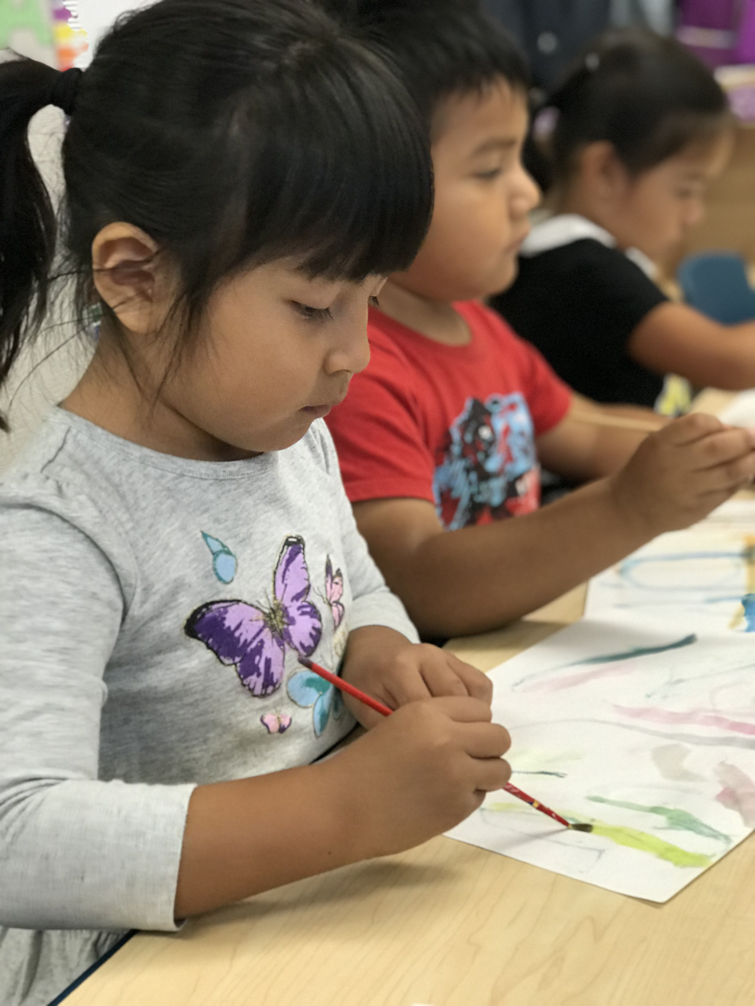

For information please call:
CVPromise
(619) 422-5005

CVPromise.org

